Specialty Ice Cream Flavors  Cashew Raisin  Chikoo (Brown Fruit)  Cinnamon  Fig  Ginger  Green Tea  Irish Stout  Kentucky Bourbon  Kesar Pista  Lychee  Mango  Taro (Purple Yam)  Gelato Flavors  Chocolate  Chocolate Chip  Chocolate Espresso  Donatella  French Vanilla  Fruitti Di Bosco  Lemon Cream  Pistachio  Salted Caramel  Strawberry Chip  Tiramisu | Additional Products  Novelty Items:  - Good Humor®  - M&M Mars®  - Popsicles  - Sandwiches  - Bars  - Character Pieces  Dairy Products:  - Milk (2% and Whole)  - Butter (Salted & Unsalted)  - Cream (Heavy Whipping – 36% & 40%)  - Whipped Cream Cans  Soft Serve & Ice Cream Mixes:  - 6% and 10% Vanilla & Chocolate  - 10% Vanilla Custard  - No Sugar Added (NSA)  - Yogurt  - Gelato  - 12% and 15% Ice Cream | 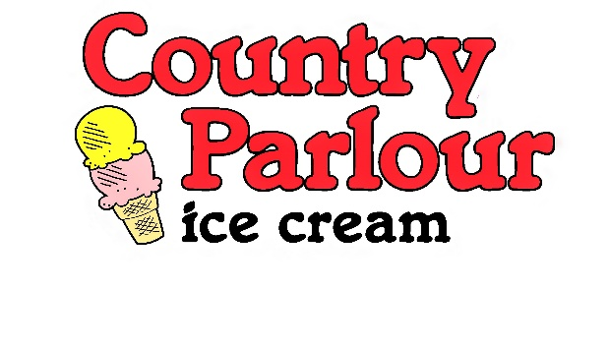  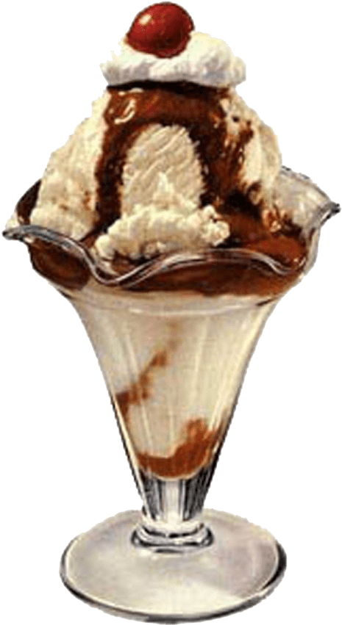  2024 Product List  Celebrating over 30 years!  2022 Product List  Celebrating over 30 years!
  - 440 237 4040
www.countryparlouricecream.com
Super Premium Ice Cream  Alley Kat  Amaretto Cherry Chunk  Apple Pie  Banana  Banana Cream Pudding  Bananas Foster  Birthday Cake  Black Cherry  Black Raspberry  Black Raspberry Truffle  Black Walnut  Blueberry Coney Island  Blue Moon  Brown Butter Bourbon Truffle  Buckeye Blitz  Butterscotch  Butter Pecan  Butter Pecan Cashew  Cannoli  Cappuccino Chip  Caramel Apple  Cherry Cheesecake  Cherry Vanilla (Whitehouse)  Chocolate  Chocolate Almond  Chocolate Blackout  Chocolate Chip  Chocolate Chip Cookie Dough  Chocolate Ho Ho®  Chocolate Marshmallow  Chubby Elvis  Cinnamon Apple Crumb  Cinna-Bun  Coconut  Coconut Avalanche  Coffee  Cookies & Cream  Cookie Monster  Cotton Candy  Cream & Praline  Double Dark Chocolate  Elk Prints  French Vanilla  Frooty Loops®  Fudge Brownie Blitz | Super Premium Ice Cream  Holy Schnikes  Key Lime Pie  Lake Erie Salt Mine  Lemon Chill  Maple Walnut  Mint Chocolate Chip  Mint Cookie Boulder  Mint Elk Print  Mississippi Mudd  New York Cheesecake  Oatmeal Cookie Crunch  Orange Dreamsicle  Orange Pineapple  Peanut Butter Strawberry Jam-wich  Peach Cream  Peanut Butter Cup  Peanut Butter Muddslide  Peanut Butter Overload  Peanut Butter Pretzel Paradise  Peppermint Stick  Pineapple Upside Down Cake  Pistachio Nut  Playdough  Raspberry Chip Cheesecake  Rocky Road  Salty Caramel Truffle  S’mores  Spumoni  Strawberry  Strawberry Cheesecake  Superman  Turtles N’ Mudd  Vanilla  Vanilla Bean  CP Shake Base  Seasonal Flavors  Berry Xmas Nog  Egg Nog  Pumpkin  Pumpkin Pecan  Pumpkin Roll  Flavors in bold print denote new items
Low Fat & No Sugar Added

Butter Pecan Mint Chocolate Chip
Cherry Vanilla Peanut Butter Fudge
Chocolate Fudge Ripple Strawberry
Elk Prints Vanilla

Frozen Yogurt
Blackberry Butter Pecan
Blueberry Cheesecake Peach
Vanilla

Sherbet

Boysenberry Pineapple
Cherry Rainbow
Lime Raspberry
Orange

Non Dairy (Vegan) Frozen Dessert

Banana Strawberry Cookies & Cream
Blue Sky Macchiato Chip
Chocolate Mint Chocolate Chip
Vanilla

Sorbet

Blueberry Pineapple
Blueberry Acai Pomegranate
Boysenberry Prickly Pear
Champagne Raspberry
Key Lime Scarlet Orange
Lemon Spiced Bourbon Apple
Mango Strawberry
Opal Basil Tangerine
Passion Fruit Very Berry
Pear Watermelon

